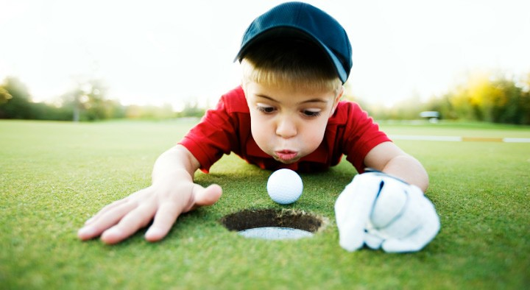
Thank You to Last Year’s Sponsors
19th Annual

Mission: To impact the lives of young people by providing educational programs that build character, instill life‐enhancing values and promote healthy choices through the game of golf.

The program is a combination of golf skills and life skills to strengthen nine core values that are inherent to the game of golf in our youth. In addition to the nine core values, The First Tee Participants are given the opportunity to develop communication skills, learn to overcome obstacles, begin setting and achieving goals, understand wellness and nutrition, while having fun and playing golf.

The First Tee of Harrisonburg is a non‐profit tax‐ exempt organization under section 501 (c)(3) of the Internal Revenue Code. Contributions to The First Tee of Harrisonburg are deductible by donors as provided in section 170 of the code.
The First Tee of Harrisonburg Tax Id number is 26‐3826410.

The First Tee of Harrisonburg
690 Garbers Church Road Harrisonburg, VA 22801 www.thefirstteeharrisonburg.org (540) 437‐4239
ACE Level ($2,500)
Riddleberger Brothers, Inc.

Eagle Level ($1,000)
A&J Development and Excavation, Inc.
Commonwealth One Federal Credit Union
DuPont Community Credit Union
Glass & Metals, Inc.
Herr & Company Building Contractors
James Madison University Kjellstrom and Lee
Lantz Construction Company Mike Layman
Pendleton Community Bank Triangle Realtors
Walt and Debby Trobaugh Wells Fargo
Renee Whitmore
W.M. Jordan Company, Inc.

Birdie Level ($500) Roger and Linda Baker Bank of the James CP&P
Terri Denton
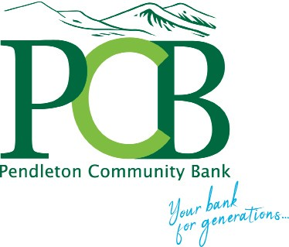
Don Largent Roofing, Inc.
Farmers & Merchants Bank Donna Harper
Integrity Home Mortgage Corp
McDaniel Contractor Service
Shenandoah Valley Implant Institute
Taylor Grove, LLC Connie Whetzel
Par Level($100) Blackwell Engineering Jim Bosserman
David Brown Charlie Obaugh Auto Group
Daniels Promotional Products
Michelle Koontz Bob and Jeri Lewis
Loomis Wealth Management Mid Atlantic Motor Werkes Myers Ford
Janell Tattersall
Wampler and Associates Rehabilitation, LLC
Paul Yoder

Golf Classic
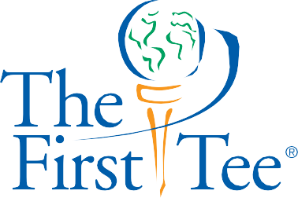Sponsored by
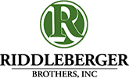

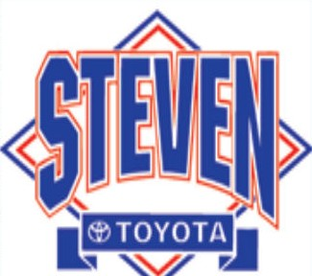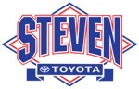Friday, October 16, 2020
at
Lakeview Golf Course 9:00 a.m.
Shotgun Start

Make checks payable to:

“The First Tee of Harrisonburg”

(Please print)

Entry Form
Sponsorship Levels
Champion Sponsor $5,000
- Includes up to two complimentary teams (includes mulligans package!)

Name Company Address City/State, Zip Phone (Business) Home: Email Sponsorship Only:
Food, Beverages, and Welcome Gift
Champion Sponsor @
Ace Sponsor @ Eagle Sponsor @
- Complimentary round of golf with cart (up to four people) at Heritage Oaks Golf Course
- Two dozen TP5 or TP5x golf balls.
- Special recognition on tournament day
- Name prominently displayed on a hole sign and scoreboard during tournament
- Banner displayed at The First Tee of Harrisonburg Rotary Learning Center for 1 year
- Recognition through The First Tee of Harrisonburg social media & webpage
** Special recognition in next year’s tournament materials.
Ace Sponsor $2,500
- Includes one complimentary team (includes mulligans package!)
- One dozen TP5 or TP5x
- Name displayed on a hole sign and scoreboard during tournament
- Banner displayed at The First Tee of Harrisonburg Rotary

Birdie Sponsor
@ Learning Center for 1 year
  - Recognition through The First Tee of Harrisonburg social

branner printing
visit us at: brannerprinting.com
printing by
Entry Fee Includes:
Green Fees, Cart Fees, Range Balls,
Food (provided by Chick-Fil-A), Beverages, and Welcome Gift
Submit entry fee with team registration.
Event will be held rain or shine.
You can drop off your registration and check at:
The First Tee of Harrisonburg Learning Center or
Mail to: The First Tee of Harrisonburg
690 Garbers Church Road, Harrisonburg, Va 22801

Prizes
*Longest Drive * Closest to the Pin*
*Hole-In-One Prizes from Steven Toyota*
*1st, 2nd, and 3rd place winners*
Par Sponsor @

Team Entry: $500/team including mulligans, powerball and
door prize raffle ticket.

Player 1 Player2 Player3 Player4 Individual Entry:
Player @$125
@$150
(includes mulligans, powerball and door prize raffle
ticket; $100 without mulligans and powerball)
media & webpage
** Special recognition in next year’s tournament materials.
Eagle Sponsor $1,000
- Includes one complimentary team
- Name displayed on a hole sign and scoreboard during tournament
- Banner displayed at The First Tee of Harrisonburg Rotary Learning Center for 1 year
- Recognition through The First Tee of Harrisonburg social media & webpage
** Special recognition in next year’s tournament materials.
Birdie Sponsor $500
- Name displayed on a hole sign and scoreboard during tournament
- Recognition on The First Tee of Harrisonburg webpage
** Special recognition in next year’s tournament materials.
Par Sponsor $100
- Name displayed on a particular hole sign during tournament
** Special recognition in next year’s tournament materials.

